ELEC 1100 Laboratory 5: Summary Sheet

Name: ________________________ Student ID:

Notes:
(1) Show demo to your TA for an attendance record; bonus mark will be given to groups who can complete all TA Checks in the first 2 hours of your enrolled lab session.
LA2 (Fri, before 15:30), LA3 (Mon, before 12:30), LA1 (Tue, before 15:30)
(2) Individually submit your completed lab summary sheet to Canvas (LA1/LA2/LA3) “Assignments” before the deadline.
LA2 (Fri, deadline 16:20), LA3 (Mon, deadline 13:20), LA1 (Tue, deadline 16:20)

Experimental Results and Analysis

Q1: Sketch what you see on the DSO (both CH1 & CH2 waves, including the voltage & time values of each division as displayed on the screen).
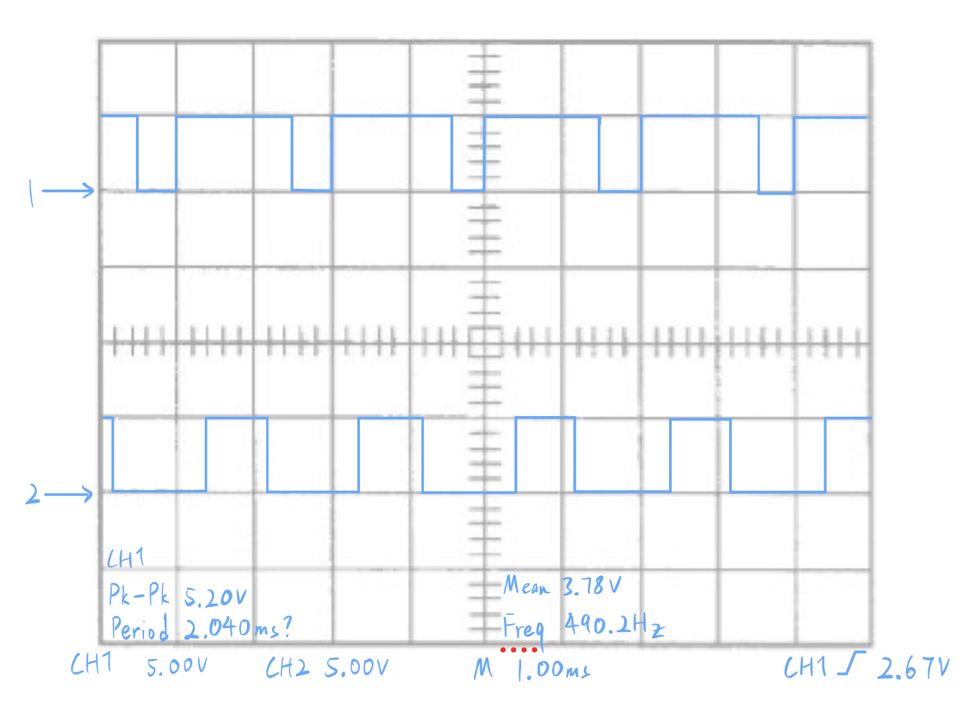
Notice: Do the sketching on the grid below by your hand, photos of DSO screen will NOT be accepted for grading.

Q2: What is the frequency (as shown on the screen) of the L_PWM and R_PWM signals?
L_PWM: ______490Hz__________ R_PWM: ________490Hz _________
Q3: What is the duty cycle (give a rough number) of the L_PWM and R_PWM signals?
L_PWM: _______75%___________ R_PWM: _______40% ___________

